EBUS course 2026 MCQs

Basic scope, tools, technique

Post video quiz (with answers)

1. A 71-year-old woman with suspected nodal metastasis from non-small cell lung cancer is undergoing EBUS-TBNA of station 4L. The bronchoscopy suite has 22G and 25G needles available in stock. How should sampling proceed, per current evidence?
A. Use the 25G needle as it has a higher diagnostic yield than the 22G needle
B. Use the 22G needle as it provides larger and more cellular samples
C. Use the 25G needle since the 22G needle is more expensive.
D. Use the 25G needle since it is the standard first-choice for mediastinal nodal staging in lung cancer.

Correct answer: B
Randomized crossover data suggest that 22G and 25G needles have similar diagnostic yield for malignant nodal disease, but the 22G needle tends to provide larger tissue fragments and a higher malignant cell count (option B).

The 25G needle has not been consistently shown to be superior in yield (option A). There is no evidence suggesting one needle option is more cost-effective than the other (option C). Guidelines do not favor 25G as the routine standard over 21G or 22G for any clinical scenario, including mediastinal staging (option D).

--------

2. After the EBUS needle has been secured to the bronchoscope, the EBUS assistant prepares to set the needle depth for needle puncture. Which of the following is a critical step prior to this latter maneuver?
A. Ensure the sheath has been adjusted so its tip is just visible in white light.
B. Extend the full needle length before the target is visualized
C. Use the angulation lever to flex the scope transducer against the airway wall
D. Activate color Doppler mode

Correct answer: A
Standard EBUS needle apparatus setup is to adjust the sheath so that its tip is just visible in the white-light view, and only then use the ultrasound image to choose the needle depth (option A correct). This should be done with the scope in the neutral position. This critical step can also be accomplished ex-vivo prior to the procedure. Failing to perform proper sheath setting risks needle deployment within the EBUS scope working channel and secondary scope damage.

Full needle extension before target confirmation is similarly unsafe (option B), and would only be attempted after setting the sheath and needle depth. Scope flexion and airway wall contact to identify the sampling target is performed only after the sheath is in the desired position (option C incorrect). Color Doppler is used selectively to identify vascular structures and does not have a role in positioning the sheath-needle apparatus (option D incorrect).

------

3. A novice cpEBUS operator has difficulty advancing into the right upper lobe bronchus with the cpEBUS scope. What is the likely primary reason for this?
A. The cpEBUS scope has a forward-oblique optical view.
B. The cpEBUS scope lacks a working channel and therefore cannot be torqued effectively.
C. The cpEBUS scope only uses radial scanning, which prevents lobar entry.
D. The cpEBUS scope can only angulate downward.

Correct answer: A

Explanation
CP-EBUS scopes are less flexible than standard diagnostic flexible bronchoscopes, and the optics are forward-oblique rather than straight ahead. Modern EBUS scopes also have a slightly larger outer diameter than conventional bronchoscopes. These design features combine to make entry into the upper lobes more challenging. Novices often realize this difference immediately when transitioning from routine flexible bronchoscopy to CP-EBUS, and the forward-oblique endoscopic view often is the most difficult to cognitively accommodate.

Option B is incorrect because CP-EBUS scopes have working channels that permit suctioning of simple secretions and introduction of tools. Option C is incorrect because radial scanning describes radial-probe EBUS and does not explain the handling characteristics of a convex-probe EBUS scope. Option D is incorrect because CP-EBUS scopes can angulate both upward and downward, although flexibility remains more limited than standard bronchoscopes.

-------

4. During an EBUS exam, a suspicious lymph node is identified, as shown below. What will be the needle’s trajectory during puncture?
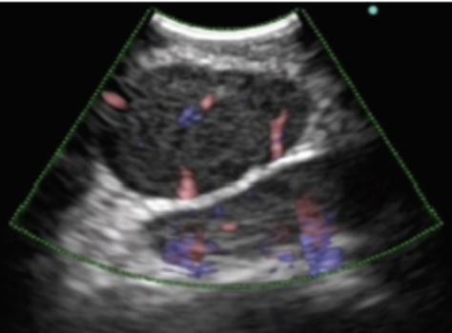

A. From the left lower corner, moving obliquely up and right.
B. From the center top of the image, moving straight down.
C. From the left upper corner, moving obliquely down and right.
D. From the right upper corner, moving obliquely down and left.

Correct answer: D

Explanation
On an EBUS image, the site of needle origin is indicated by the orientation marker (usually a solid small blue-teal oval). By standard convention, the marker should align with the cephalad portion of the scope and thus is often placed in the right upper corner. While this can be adjusted per operator preference to be located in any corner, the marker will always indicate the position from which the needle will enter the EBUS image. In the stem image, the orientation marker is in the standard position, the right upper corner. Therefore, the needle will appear from this position and move obliquely down and left (option D correct). To anticipate precise nodal sampling, EBUS bronchoscopists will therefore often place the intended sampling target at a slightly left-sided position on the screen to ensure a ‘center strike’ needle puncture.

Options A and C are incorrect because they violate the convention described above. Option B is incorrect because the needle never appears in the center and proceeds straight down, regardless of image orientation preferences.

------

5. Immediately after needle puncture of a station 4R lymph node, the image below is seen on the EBUS monitor. What should be the immediate next step in technique?
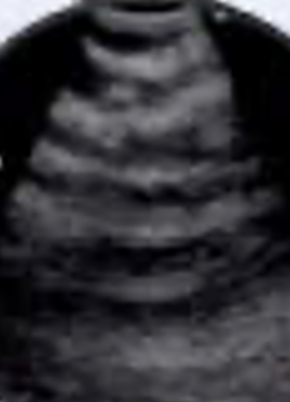

A. Retract the needle back into the scope and reattempt puncture.
B. Retract the needle back into the scope and readjust the depth of the sheath-needle apparatus.
C. Stabilize the needle and ensure scope angulation and anchoring against the airway wall
D. Adjust the gain on the EBUS console.

Correct answer: C
The image shown is of a reverberation artifact seen when contact between the airway wall and the probe/balloon is lost. This is a fairly common occurrence during needle puncture when the needle encounters some resistance to target penetration and results in the scope being pushed back/away from the airway wall, resulting in loss of contact. The resistance encountered can be at the level of the wall (e.g., cartilaginous ring) or the target itself (e.g., fibrotic/calcified node). The former scenario may prevent needle entry completely, while in the latter the needle has partially entered the target. The EBUS bronchoscopist should first troubleshoot which has occurred by stabilizing the needle and attempting to better anchor the scope against the airway wall (option C). A slight partial retraction of the needle to relieve resistance may also assist in re-apposition of wall and scope. Occasionally, if the scope-wall decoupling was significant, the bronchoscopist will visualize the incompletely penetrated needle on endoscopic view.
Option A is not the first step as the needle may already be in the target. Complete retraction should only be performed if troubleshooting fails to reacquire a target image to reliably guarantee sampling. Option B is incorrect because readjustment of the sheath would only be required if there was concern of sheath migration during needle puncture. Option D would not solve the issue of loss of airway-scope contact.

